Chapter 13, Problem 76.

Using Fig. 13.138, design a problem to help other students to better understand a wye-delta, three-phase transformer and how they work.
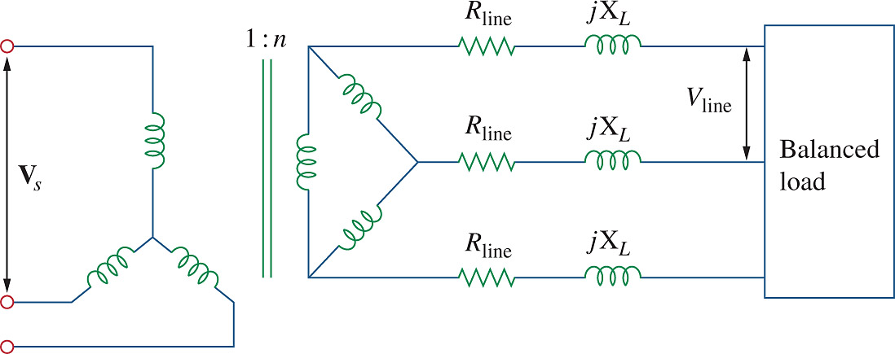

Figure 13.138
For Prob. 13.76.

